Project Design Phase
Solution Architecture

Date | 30 September 2026
Team ID | SWTID-2026-8886
Project Name | Implement Client Script and UI Policy for Incident
Maximum Marks | 4 Marks

Solution Architecture:
Solution architecture is a complex process – with many sub-processes – that bridges the gap between business problems and technology solutions. Its goals are to:
- Find the best tech solution to solve existing business problems.
- Describe the structure, characteristics, behavior, and other aspects of the software to project stakeholders.
- Define features, development phases, and solution requirements.
- Provide specifications according to which the solution is defined, managed, and delivered.

Example - Solution Architecture Diagram:

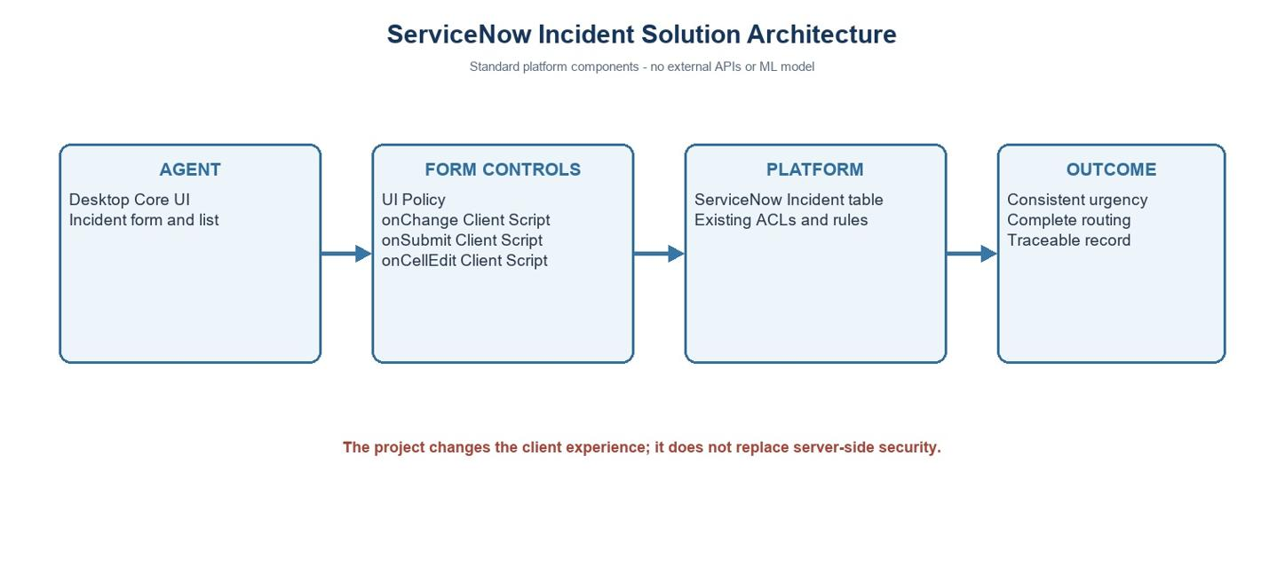
Figure 1: Architecture and data flow of the voice patient diary sample application
Reference: https://aws.amazon.com/blogs/industries/voice-applications-in-clinical-research-powered-by-ai-on-aws-part-1-architecture-and-design-considerations/

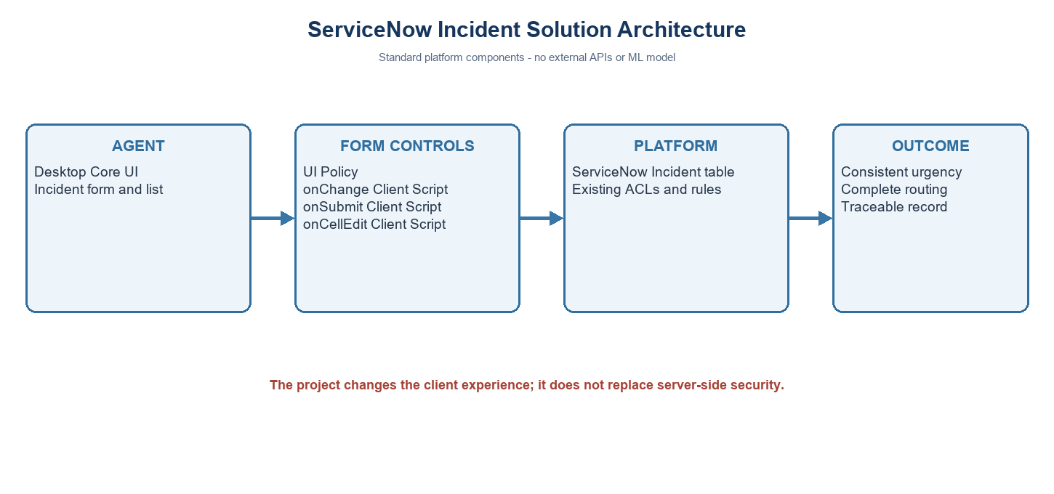
Incident client control architecture
Component | Responsibility
Incident form/list | Collect impact and routing values.
UI Policy | Require group and assignee; lock urgency at high impact.
Client Scripts | Set urgency, validate submit, block list State edit.
Incident table | Platform persistence and existing server controls.
Project note: values use the standard Incident choices where Impact 1 and Urgency 1 represent High. Confirm field names and values in the target instance.

